**Electrodynamics HW Problems**

**05 – Conservation Laws**

1. Charging Capacitor
2. Poynting vector of a solenoid
3. Energy flow in a coax – Part I
4. Energy flow in a coax – Part II
5. Feynman Rotator
6. Stress tensor for a solenoid
7. Force between two point charges
8. Stress in a charged plate capacitor

**5.01. Charging capacitor** [Dubson SP12, Kinney SP11]

A capacitor with circular plates of radius *R* separated by distance *d* << *R* is being charged by a steady current *I*. The plates are sufficiently close that fringe effects can be ignored.

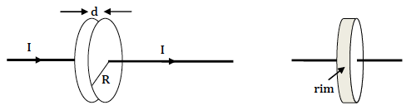

**(a)** Compute the magnitude of the B-field between the plates at all distances *r* from the center of the plates (r < R & r > R). Sketch the magnitude of the B-field vs. *R*.

**(b)** Compute the Poynting vector  (magnitude and direction) on the *rim* of the capacitor, between the plates, at *r* = *R*. (The "rim" is the ribbon of area at *r* = *R* between the plates; see the diagram.)

**(c)** Show that the rate at which the capacitor's stored energy is increasing  is equal to the rate at which field energy is entering through the rim:.

**5.02. Poynting vector of a solenoid** [Dubson SP12]

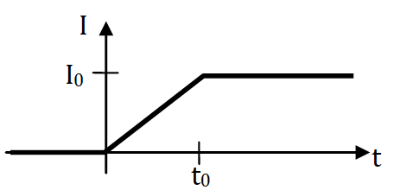Consider a very long solenoid of length *L*, radius *r*, and turns per length *n*. The current *I* in the solenoid is linearly ramped from *I* = 0 to *I* = I0 over a period *t*0 as shown in the graph.

**(a)** Integrate the magnetic field energy density to derive a formula for the total field energy stored in the solenoid at times *t* > *t*0.

**(b)** Solve for the electric field everywhere at times 0 < *t* < *t*0.

**(c)** Solve for the Poynting vector  (direction and magnitude) at *r* = *R* (just inside the walls of the solenoid) as a function of time *t*.

**(d)** Show that the total field energy/time passing from the walls of the solenoid into its interior, when integrated from *t* = 0 to *t* = *t*0, gives the same total energy as you computed in part (a).

**5.03. Energy flow in a coax – Part I** [Pollock FA11, Kinney SP11]

We now want to investigate energy flow in a cylindrical coax cable. For now, let’s just look at fields constant in time, not varying in time. Assume that constant current *I* flows in the +*z* direction on the inner wire and that total current *I* flows in the opposite direction in the shell. Also assume that there is a constant voltage difference *V* between the wire and the shell, as shown.

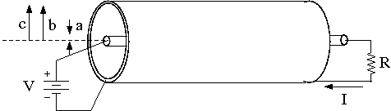

**(a)** For this steady current and voltage case: Find **E** and **B** everywhere in space. You may assume that the coax cable (wire plus shell) is neutral.

**(b)** Calculate the Poynting vector **S** everywhere. The magnitude of **S** gives the energy flux density and represents the power per area moving through space. Does its *direction* make sense for the coax? Integrate this flux through the cross sectional area of the coax to find the power transported down the coax line. Does your answer make sense relative to the circuit maintaining the current and voltage? Briefly comment!

**5.04. Energy flow in a coax – Part II** [Kinney SP11]

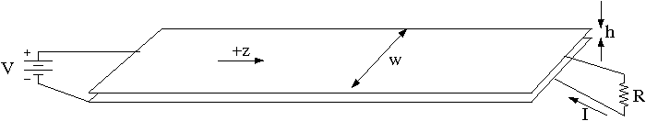We now want to investigate energy flow in a different type of coax cable. Again, we will only look at fields constant in time, not varying in time. The coax consists of two infinitely long flat parallel “ribbons” of width *w* and separation *h*, as shown. The width is much greater than the separation, so that *w >>h*. One can assume therefore any piece of the coax looks like infinite plane capacitors or infinite planes of surface current.

**(a)** Again, a warm-up question: Find the capacitance per length and the self-inductance per length of this ribbon coax. Multiply the capacitance per length by the self-inductance per length. Comment on how this constant depends on the coax cable geometry and compare it to your answer to part (a) of Question [5.3].

**5.04. (cont.)**

**(b)** Now assume that a constant total current *I* flows in the +*z* direction on the upper ribbon and that total current *I* flows in the opposite direction on the lower ribbon. Also assume that there is a constant voltage difference *V* between the upper and lower ribbons (as shown). As before, find **E** and **B** everywhere between the ribbons; we will neglect the edge effect fields. Again, the two-ribbon coax is neutral.

**(c)** Calculate the Poynting vector **S** as in Question [5.3]. Does its direction make sense for this coax? Integrate this flux through the cross sectional area of the coax to find the power transported down the coax line. Does your answer make sense relative to the circuit maintaining the current and voltage?

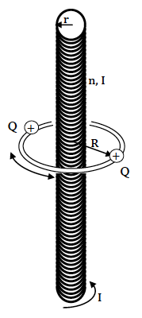**5.05. Feynman Rotator** [Dubson SP12]

In volume 2 of the Feynman Lectures on Physics, the author poses this paradox: Two small spheres, each with mass m and positive charge +*Q*, are attached to a light plastic horizontal ring of radius *R* of negligible mass that can spin without friction around its vertical axis. On the axis is a long, stationary solenoid of length *L*, with *n* turns per length, and radius *r*, initially carrying current *I*, as shown. When the current in the solenoid is turned off (by an automatic timer), there is an induced E-field at the location of the charges. This E-field pushes the charges, so the ring starts rotating. But wait! While the current was on, everything was stationary. After the current turns off, the ring is spinning. Doesn't this violate Conservation of Angular Momentum? (Note: the angular momentum due to the moving conduction electrons in the current is completely negligible.)

**(a)** What is the magnitude of the E-field at the location of the charges when the solenoid current is decreasing to zero. Write the answer in terms of dI/dt.

**(b)** If you integrate the force on the charged spheres over the time period that the current decreases to zero, you get the change in momentum of the spheres. How fast are they moving after the field is turned off?

**(c)** What was the magnitude and direction of the total angular momentum in the field before the current was turned off?

**5.06. Stress tensor for a solenoid** [Rogers SP09]

**(a)** Determine the 9 elements of the Maxwell stress tensor inside an infinite solenoid. Display your answer as a 3x3 matrix. You are at the beginning of understanding the forces that solenoids must withstand when they generate magnetic fields. Now let’s use what you found to do some mechanical design on a high field magnet.

**(b)** Design a solenoid that can generate a magnetic field of 10 Tesla with 100 amps maximum current. Let’s assume that the solenoid is going to fit inside a region no more than 0.5 meters on each side, and that the inner diameter of the solenoid is 25 mm. List the number of turns and the final dimensions of your solenoid. Feel free to use the infinite solenoid formula to estimate the magnetic field, but try to do a reasonable job estimating a number of turns that is consistent with some reasonable diameter wire.

**(c)** Let’s assume that the solenoid you designed in part (b) is described by the stress tensor in part (a). What is the total force on each of the circular ends of the solenoid? What is the total pressure acting on the cylindrical side of the solenoid? If the materials of the coil are too weak, will the coil explode, crush itself, or do some other nasty thing? In other words, in which directions are the various forces?

**(d)** The solenoid coil needs to be able to withstand the various forces and pressures. Estimate the required ‘tensile strength’ of the materials necessary to keep the coil from destroying itself. Steel is a bad idea for such high magnetic fields (why?). Find another metallic structural material that could work.

**5.07. Force between two point charges** [Kinney SP11, Munsat FA10]

**(a)** Consider two equal point charges *q* separated by a distance 2*a*. Instead of using Coulomb’s law to find the force on one of the charges, use the Maxwell stress tensor  integrated on the surface around a volume containing the point charge. You might guess that a small spherical surface around one of the charges would be best, but you’d be wrong! Since any volume containing the charge will work, use the volume defined by a circular flat surface of radius *R* on the plane in which each point is equidistant from the two charges, plus a hemispherical surface of radius *R* around one of the charges (centered on the point halfway between the charges) in order to form a closed surface. You only need to set up the correct integrals for each surface; you do not need to perform the actual integrations, but they should be in a form ready to be integrated.

**(cont…)**

**5.07. (cont.)**

**(b)** Now perform the calculation again, but let  first. Then your closed surface is the entire “equidistant” plane between the charges and a hemispherical surface “at infinity.” Give an argument for why it might be safe to assume that the surface integral on the hemisphere vanishes in this limit, so that we don’t need to actually calculate it. Assuming that the hemispherical part of the flux vanishes, now calculate the flux integral on just the infinite plane. Does your answer agree with that of part (a)?

**5.08. Stress in a charged parallel plate capacitor** [Kinney SP11]

Consider a large (“infinite”) parallel plate capacitor, with the lower plate (at ) carrying the charge density , and the upper plate (at ) carrying the charge density .

**(a)** Calculate all nine elements of the Maxwell stress tensor  in the region between the plates, and write out the results in a 3x3 matrix. Also determine the Poynting vector  in the region between the plates.

**(b)** Find the force per unit area on the top plate using your  and the relation



In this formula, **F** is the total force on the charges in *V*. To use it in this case, just use a volume which is a very thin slab of  of area A and negligible thickness (so that we don’t have to calculate the thin edges of the slab. Does the direction of **F**/A make sense, using what you know about the Coulomb force? Are there any shear forces?

**(c)** Using the information you already have calculated, and using the interpretation in terms of densities and fluxes, what is the momentum per unit time per unit area crossing the *xy*-plane (*z* = 0) plane? What is the direction of this momentum? Is your answer the same for a plane parallel to the *xy*-plane, but located just below ?

**(d)** When the charges on the plate absorb the momentum flux you found in part (c), momentum seems to disappear because inside the metal, the fields are all zero, hence  is zero. Therefore the flux into the volume holding the charges (on the gap side) is just equal and opposite to the flux flowing out of the gap. What external force  per unit area is required to keep the total mechanical momentum of the charge equal to zero? Does your answer agree with that you found in part (b)?